**STAT 477/577 – Class Activities**

**Unit 1 – Section 2**

**Distributions for Counts: Bernoulli, Binomial, and Multinomial Distributions**

Binomial Activity: Flip a coin 10 times. If you don’t have one handy, google “flip a coin” and a coin flip simulation should appear. Enter the outcomes for your 10 flips in the table below.

Data Make a Frequency Table

|  |  |
| --- | --- |
| Flip | Outcome |
| 1 | F |
| 2 | T |
| 3 | T |
| 4 | T |
| 5 | F |
| 6 | F |
| 7 | T |
| 8 | F |
| 9 | T |
| 10 | T |

|  |  |
| --- | --- |
| Outcome | Count |
|  |  |
|  |  |
|  |  |

Make a Bar Graph

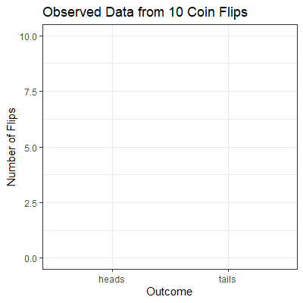

Assuming the coin is fair, find the probability of obtaining your observed result.

Multinomial Activity: Google “roll a die”. Click on the 10-sided die to add it to the window and then click on the 6 sided-die to remove it. Assign the color blue to outcomes 1 – 3, green to outcome 4 – 7, and red to outcomes 8 – 10. Enter the outcomes in the table below.

Data

|  |  |  |  |  |
| --- | --- | --- | --- | --- |
| Flip | Outcome |  | Flip | Outcome |
| 1 |  |  | 11 |  |
| 2 |  |  | 12 |  |
| 3 |  |  | 13 |  |
| 4 |  |  | 14 |  |
| 5 |  |  | 15 |  |
| 6 |  |  | 16 |  |
| 7 |  |  | 17 |  |
| 8 |  |  | 18 |  |
| 9 |  |  | 19 |  |
| 10 |  |  | 20 |  |

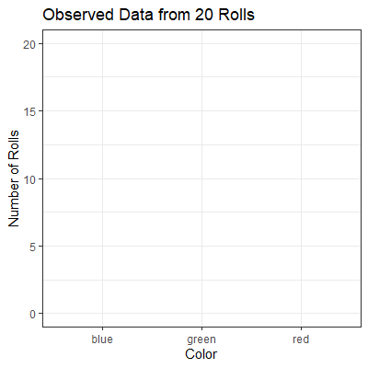Make a Frequency Table Make a Bar Graph

|  |  |
| --- | --- |
| Outcome | Count |
|  |  |
|  |  |
|  |  |
|  |  |

Assuming the die is fair, find the probability of obtaining your observed result.